**STUDY OF THE CLIMATE OF LOWESTOFT**

**ABSTRACT**

In this project the primary objective is to get a basic understanding about the weather of Lowestoft. The visualisation would be done for climatic characteristics such as rain downpour, air frost days per month, and the duration of sun per month. From the analysis we can conclude that the duration of sun hours was maximum in the month of June and July. The air frost days analysis showed that it has not exceeded the value of 28 days for a particular month. The downpour of rain was maximum in the month of November.

**INTRODUCTION**

The dataset considered for this project has been taken from the meteorological website of the United Kingdom. The city that has been considered for analysis is Lowestoft. The timeframe considered for the analysis is between 1914 to 2022. The duration of sun hours, air frost days, and the rain downpour has been analysed for Lowestoft.

The variables considered for the analysis is as below:

* yyyy: Year of analysis
* mm: Month number of analysis
* Mon: Month name taking the first 3 characters of a particular month. Eg: December has been taken as Dec.
* tmax(degC): Maximum temperature in Celsius
* tmin(degC): Minimum temperature in Celsius
* af(days): Number of air frost days in a month
* rain(mm): Intensity of rain downpour in a month
* sun(hours): Duration of sun in hours

(Historic station data, n.d.)

**ANALYSIS**

The initial visualisation is a line plot which would show us the duration of sun hours in the sky for a particular month:

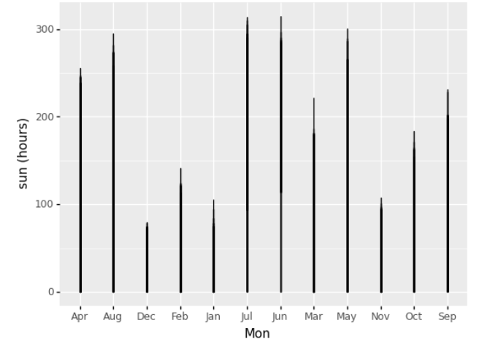

*Figure: Duration of sun hours* *per month*

From the above picture we can conclude that the maximum duration of sun hours was observed in the month of June and July in Lowestoft

The next visualisation is a boxplot which would focus on the number of air frost days in a particular month:

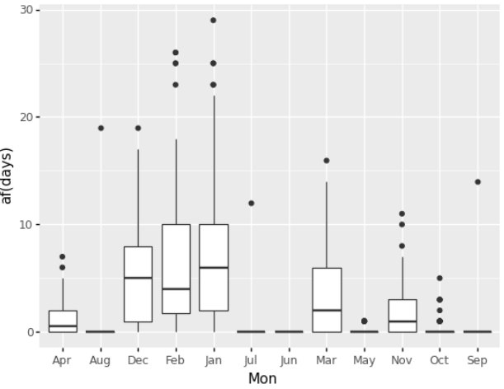

*Fig: Number of Air Frost Days per month*

From the above picture it can be concluded that the average maximum number of air frost days was observed in the month of January followed by the month of December. There are many outliers present for the month of January and February.

The final visualisation is a boxplot which would focus on the intensity of rain downpour for a particular month:

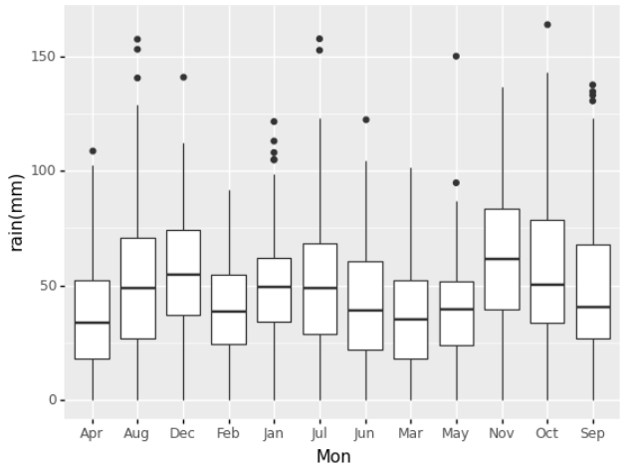

*Fig: Intensity of rain downpour per month*

From the above picture it can be concluded that the average intensity of rain downpour was maximum in the month of November followed by the month of December. For the month of August and July there are a lot of outliers.

**CONCLUSION**

In this project the climate analysis for Lowestoft has been done. We have observed that the month of June and July had the maximum duration of sun hours. In Lowestoft, the month of January had the highest average number of air frost days. There were multiple outliers present in the boxplot. The month of November had the highest average rain downpour measured in millimetre which was followed by the month of December

**REFERENCES**

# Historic station data. (n.d.). Retrieved from https://www.metoffice.gov.uk/research/climate/maps-and-data/historic-station-data